**PROJECT REPORT TEMPLATE**

**BUILD AN EVENT MANAGEMENT USING SALESFORCE**

**INTRODUCTION**

Events create opportunities for people to connect with on area, spend time together, celebrate and experience the diversity of cultures and foster creativity and innovation.

Events management strategy Events are widely acknowledged as presenting opportunities as a strong economic and tourism generator as well as bringing a range of communities and social benefits to their host destination.

**OVERVIEW**

This project leads to combines creativity and relationship with customers.

It leads to create and organize the events and managing toward customer’s suggestion, improving contacts over vendors and enhances economic records and growth rates.

**PURPOSE**

To satisfy customer expectations, to understand concepts of the event management, to study the different type of events, to analyze the role of creativity in event management process.

**PROBLEM DEFINITION & DESIGN THINKING**

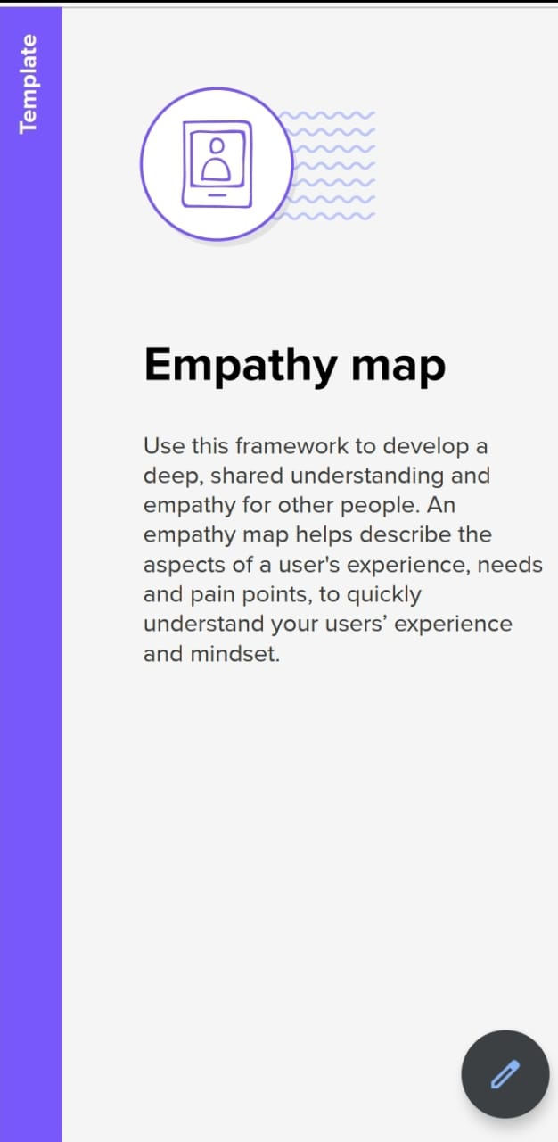

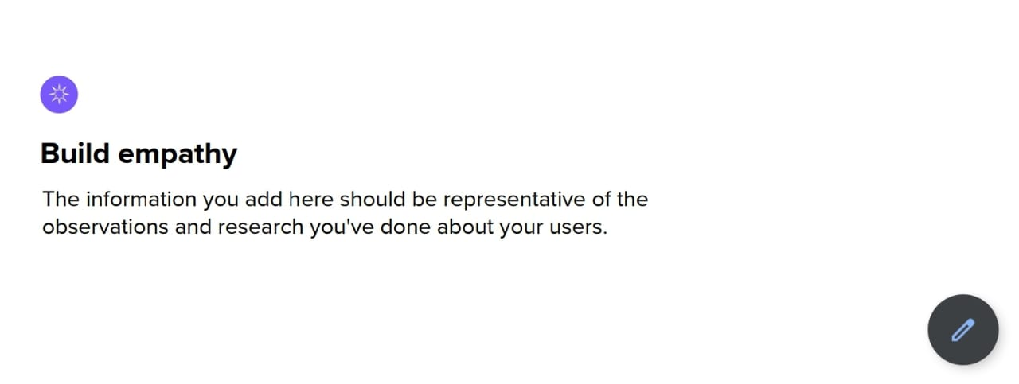

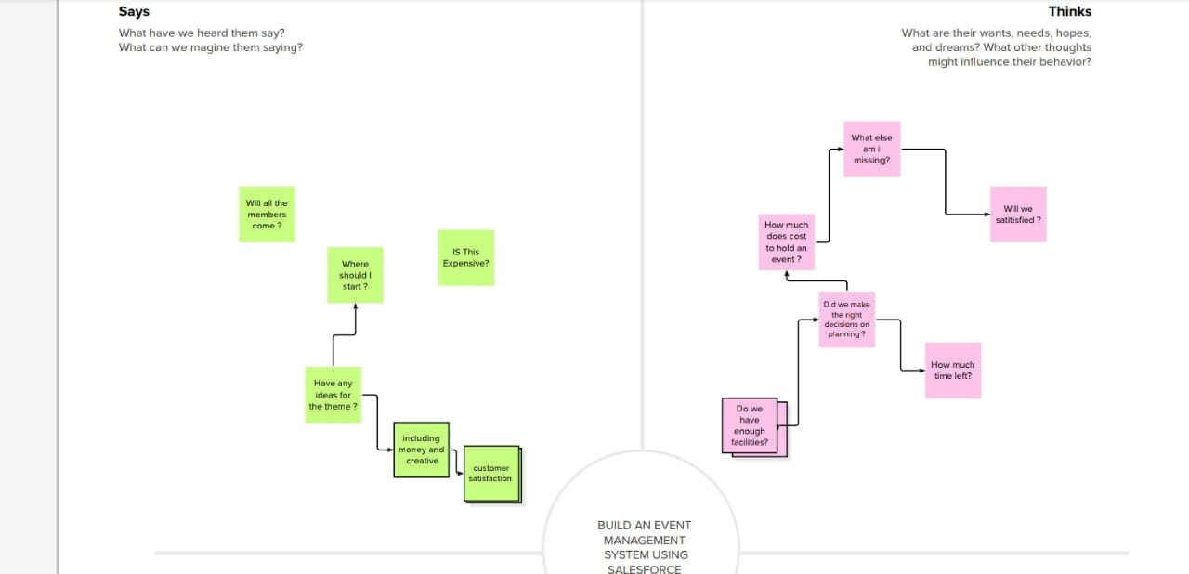

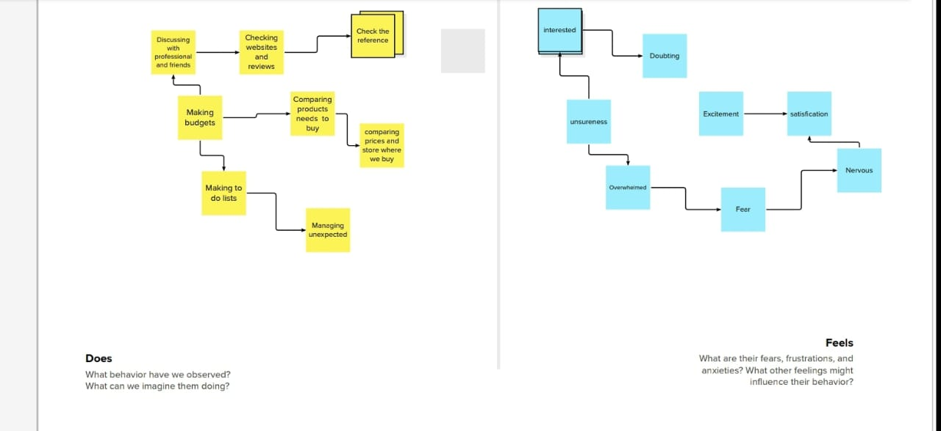

**IDEASTION AND BRAINSTORMING**

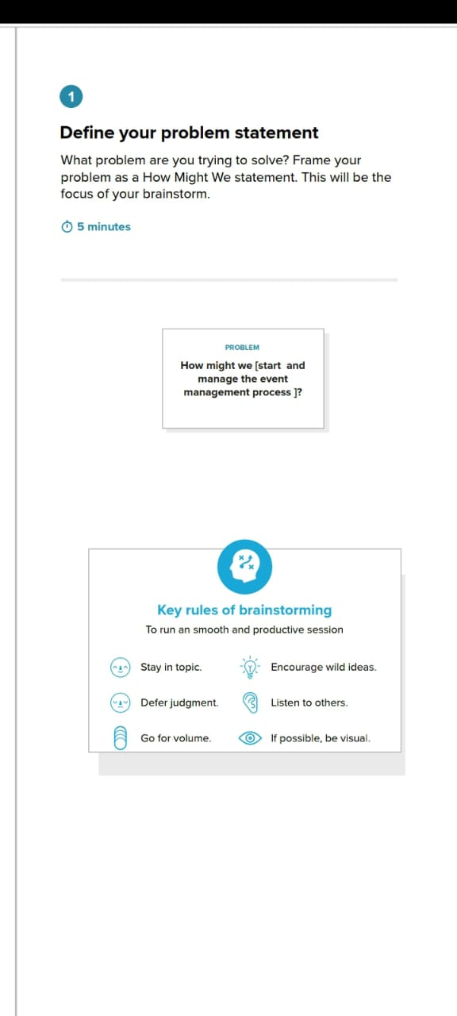

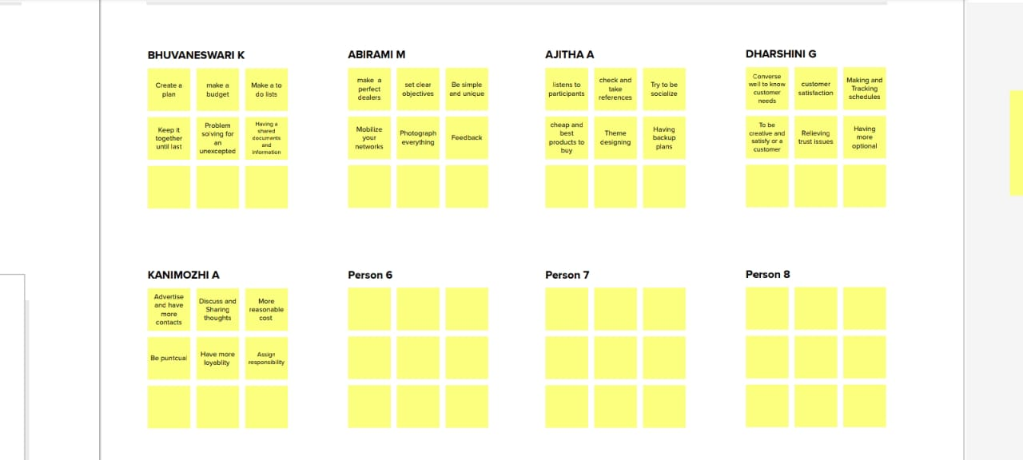

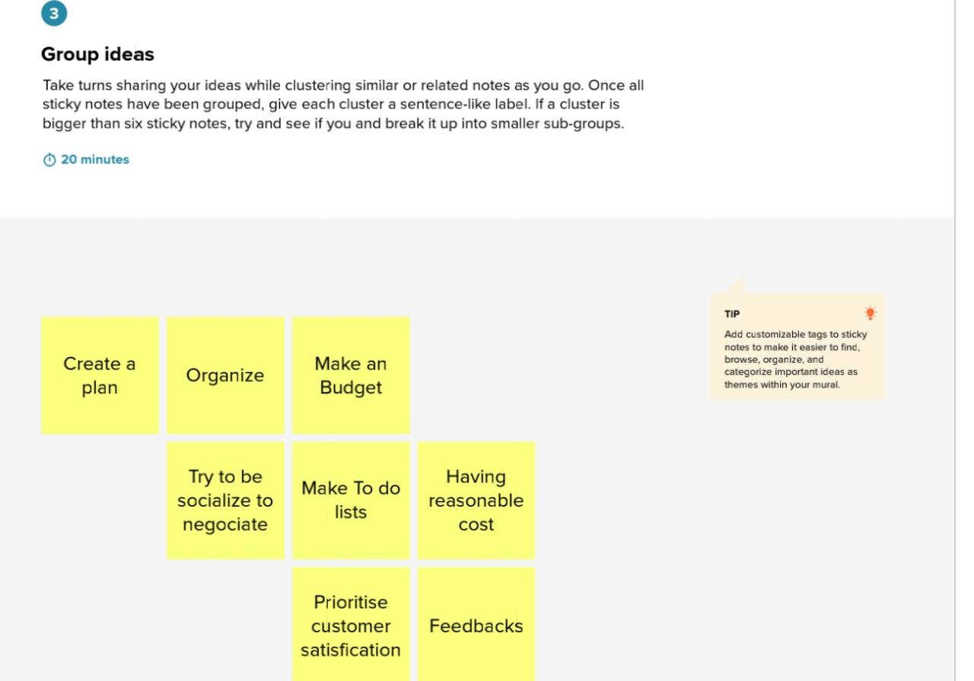

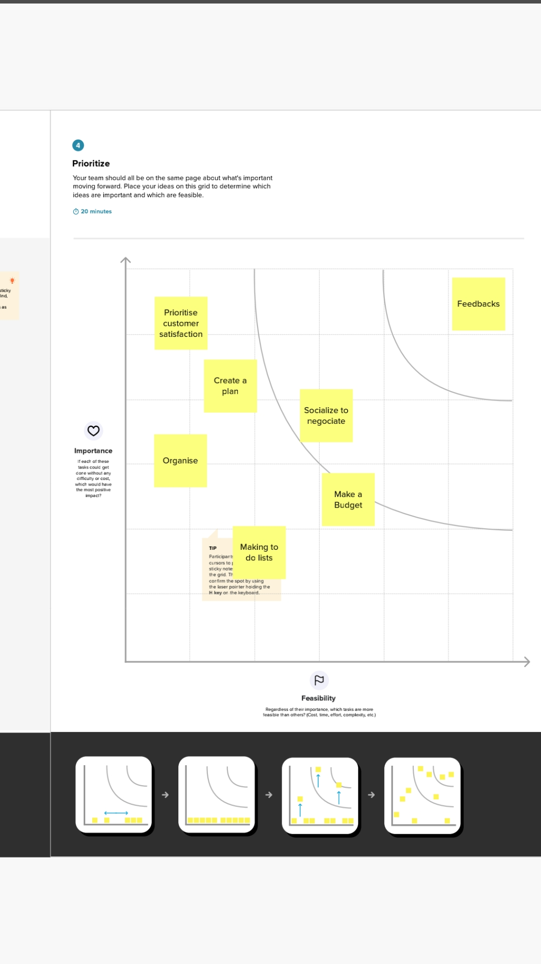

**RESULT**

The results and benefits measure the progress toward achieving the overall plan. These measurable results and benefits will be observable within the targeted population once the event is complete , determining the extent to which the identified objectivs were achieved .

Outcomes are the short- term and medium-term effects of the event on the stakeholders .Examples of outcomes include new knowledge , increased skills, increased understanding, and increased participation in various event related activities.

**ADVANTAGES**

There are many advantages to creativity among managers in an Event management company.

* Achieving growth
* Mentoring teams in the workplace
* Finding unlikely perspective within the business.

**DISADVANTAGES**

* COST: In need to pay them in addition to other event costs.
* COMPANY KNOWLEDE: The event management come any does not know anything about your company unless tell them.

**APPLICATION**

* All in one event management software.

Grant your team access to tracking performing indicators in real time adjust your event accordingly.

* Time saving

Event management software saves you time by having all of your task centralized in a single platform.

* Event automation

Event planners have a lot to think about to organize remarkable events.

* Increases engagement rate at events

The right event management software includes all the tools to engage with your audience.

* Access to valuable real time data.

When choosing an event management platform , you should make sure that valuable data about an event can be backed up and display in dashboards in a user- friendly way.

* Personalized reports for continuous improvement.

When the event is our, you can access personalized reports with lots of valuable information.

**CONCLUSION**

Once the event is underway, the team members should be able to turn to the manager for guidance and support, but not feel as if they are being micromaged. The advantage of event marketing is to move from the one – on – one basic of selling to group selling. Group selling lets your company present itself and its products to several prospects at the same time or at the same location.

**FUTURE SCOPES**

The main objective of the event management system is to manage the details of the Event, Employee, Booking, Venue, Package. It manages all the information about event , Enquiry, Package, Event. The project is totally built at administrative end and thus only the administrator is guaranteed the access, The team members and customers can also be tracking where the event management process is at.

**APPENDIX**

Source code

